Introduction
When discussing topics to focus on for our research project, our group was immediately intrigued by recent US inflation. It is a concept we are all too familiar with recently, and has impacted each of our lives. Going to the grocery store, filling a car up with gas, or shopping on Amazon, recent US inflation has raised prices across the board. Beyond simply looking at inflation, we wanted to compare recent price increases with wage increases. As master’s students about to enter the workforce, we have heard often about how wage increases have not kept up with inflation recently, and we wanted to investigate the validity behind this.
For our data, we came across an interesting comparison of wage increases and inflation on Statista. However, this comparison only went back to 2020, and the wage increase data was only an average value. We wanted data that went back before Covid, so we could have a baseline to compare to. Additionally, if we are to run a regression model, we need data that includes a variety of variables. Looking into the sources of the graph on Statista, we found that the wage data came from the Federal Reserve Bank of Atlanta, and the inflation data from the Bureau of Labor Statistics. We investigated the data from the Atlanta Fed, which eventually led us to a dataset that divided wage growth into a variety of subcategories. This dataset showed the wage growth for race, age, sex, education, geographic region, industry, and a variety of other variables dating back to 1997. In the dataset, an individual's percent change in wage in month t is computed as 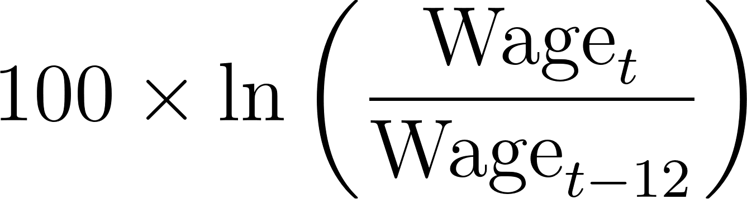. When combining this data with CPI-U data from BLS, we are able to build a graph similar to the original Statista comparison of inflation and wage growth, but over a longer time frame and with additional variables so that regression analysis will be possible.

Literature Review
Inflation Inequality: Measurement, Causes, and Policy Implications by Xavier Jaravel discusses how inflation impacts different groups in society unevenly, especially across the income distribution. Lower-income households experience more inflation because they spend a larger share of their income on necessities that have rapid price increases (like food, energy, or housing). He highlights other potential drivers of this inequality, such as innovation, trade, and non-homothetic preferences. Using our data we should be able to estimate the average differences in inflation across different regions and demographics in the United States and see the income effect of inflation.
Factors Affecting Recent Food Price Inflation in the United States by Michael Adjemian discusses the debate in the field of economics about the main causes of the US inflation surge since 2021. The main potential causes are lockdowns, supply chain disruptions, and commodity shocks (e.g. Ukrainian wheat exports). In our data, we could potentially include lagged dummy variables such as when covid lockdowns began, or when the Russo-Ukrainian war began to estimate the effects of these events on overall US inflation.
This research is particularly relevant in understanding the broader socioeconomic impacts of inflation on wage dynamics in the U.S. As inflation persists, policymakers, economists, and businesses need insight into how different regions and population segments are affected. By disentangling the relationship between wage growth and inflation, this research can provide benefits in several aspects: policy strategies, labor market analysis, regional development, business strategy. This will possibly provide some insights for the policymakers on the impact of inflation across regions on wage growth.
In their study, Schmitt-Grohé and Uribe (2022) investigate the dynamics of inflation in the U.S. from 1900 to 2021, focusing on the permanent component of inflation. The rise in inflation lately after 2020 has brought attention to workers’ struggles in keeping up with their wages growth rate. The increasing prices due to inflation have hit middle income earners harder as their wages are not increasing at the rate. The reasons behind this include the increase in goods prices such as food, housing, and energy and disruptions in the supply chain leading to shortages, in critical industries. Despite an increase, in wages in industries, many workers still struggle as real wage increases fail to keep up with inflation’s impact on their purchasing power. This situation makes negotiations over wages difficult as employers are hesitant to raise salaries significantly because of growing operational expenses. The time gap between spikes in inflation and adjustments in wage growth differs by region with some areas facing inflation effects based on their industry mix resulting in varying rates of wage growth, across different regions of the United States. Developing an understanding of this connection is crucial, for creating specific economic strategies to lessen the lasting effects of inflation on differences, in wages (Jaravel, 2020; Adjemian et al., 2023; Schmitt-Grohé & Uribe, 2022).

Model
In order to explore the recent relationship between real wages, inflation, and whether it is different between regions/demographics, we will employ an empirical model. Here we offer suggestions to establish a foundation to center our further research and improve the rigor of our final model. One choice is a random effect model of the form:
Where:
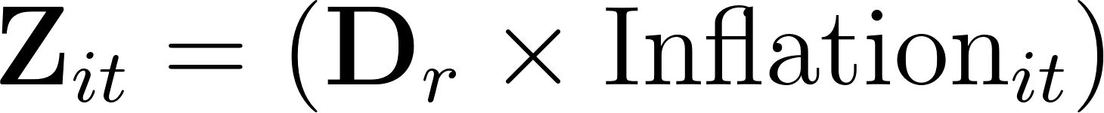

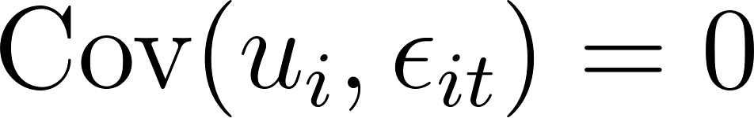
 represents wage growth for each region/demographic at each time,  represents our region/demographic dummies,  represents the interaction terms to test whether this relationship is heterogenous,  represents time-fixed effects and  represents other economic variables such as unemployment, interest rates, GDP, dummy variable for the Covid-19 pandemic, etc. Of course,  is our coefficient vector of interest. By exploiting the between and within variation in panel data, we hope to achieve a rigorous estimate of the causal effect.

Sources
Literature
https://onlinelibrary.wiley.com/doi/full/10.1002/aepp.13378
https://www.annualreviews.org/content/journals/10.1146/annurev-economics-091520-082042
https://www.columbia.edu/~mu2166/covid_inflation/covid_inflation.pdf

Data
https://www.statista.com/statistics/1351276/wage-growth-vs-inflation-us/
https://data.bls.gov/dataViewer/view/timeseries/CUSR0000SA0
https://www.atlantafed.org/chcs/wage-growth-tracker

